UNIVERSITY OF LIVINGSTONIA

LAWS CAMPUS
FACULTY OF EDUCATION
DEPARTMENT OF EDUCATION IN INFORMATION AND COMMUNICATION
TECHNOLOGGY
NED SMART EXAMINATION MANAGEMENT SYSTEM (NED-SEMS)
BY
LEONARD PONJE MLUNGU
(ICT/01/25/22,ict-01-25-22@unilia.ac.mw)
A PROPOSAL RESEARCH DOCUMENT SUBMITTED TO THE ICT DEPARTMENT IN
PARTIAL FULFILLMENT OF THE REQUIREMENT FOR THE AWARD OF THE DEGREE OF BACHELOR OF SCIENCE IN INFORMATION, COMMUNICATION, AND TECHNOLOGY OF THE UNIVERSITY OF LIVINGSTONIA.
SUPERVISOR
MR JOHN MEMORY BANDA
DATE
15TH NOVEMBER,2025

Abstract
At present, the examination process within the Northern Education Division (NED) relies on a manual and semi-digital workflow that begins at the Education Division Manager (EDM) office which appoints subject teachers from various schools to serve as item writers [1]. These teachers prepare draft examination papers based on the national syllabus and submit them to the EDM office for moderation, where other teachers review the content for accuracy and fairness. Approved papers are then distributed to Headteachers via email or WhatsApp, who pass them to school examination officers for printing and distribution. After students complete the exams, teachers manually mark scripts, compile results, and forward them up the chain through the Headteacher to the EDM office for consolidation and official release. This process is time-consuming, error-prone, and lacks centralized control, transparency, and analytical insight.

To address these challenges, the NED Smart Examination Management System (NED-SEMS) is proposed as an intelligent web-based platform that will automates and secures examination workflows by supporting role based access for all key actors ensuring secure exam paper creation, moderation, controlled distribution, and results submission. It will provide real-time dashboards, automated report generation, and an AI module capable of detecting irregularities and predicting performance trends which will be developed using PHP and MySQL for core system operations, Python for AI analytics, and standard HTML, CSS, and JavaScript for the user interface. NED-SEMS enhances efficiency, transparency, and accountability in the management of examinations by using Agile development methodology, the system will evolve through iterative refinement and continuous user feedback, transforming the Division’s fragmented processes into an intelligent, centralized, and data-driven examination management environment.

Table of Contents
Abstract i
1.0 Introduction 1
2.0 Problem statement 1
3.0 Scope of the Development Project 2
3.0.1 Included features 2
3.0.1.1 User Management 2
3.0.1.2 Examination Management 2
3.0.1.3 Performance and Reporting management 2
3.0.1.4 Prediction and decision support 3
3.1 Excluded Features 3
3.2 Before Installation 3
3.3 After installation 3
3.4 System Integration Considerations 3
4.0 System Personnel Future 4
4.1 System End Users 4
4.2 Project Team 4
4.3 System Owner 5
5.1 DFD 6
5.1.1 Figure 1: Context diagram for the current system 6
5.1.2 Level zero diagram for the current system 7
5.1.3 Figure 3: Context diagram for the proposed system 8
6.0 System Requirements 11
6.2 Interface Requirements 12
6.3 Non-Functional Requirements 12
6.3.1 Table 3: System-Related Non-Functional Requirements 12
6.3.2 User-Related Non-Functional Requirements 13
7.0 Engineering Plan 13
7.1 System Lifecycle Constraints 13
7.1.1 Development Constraints 13
7.1.5 Maintenance & Retirement Constraints 14
7.2 System Delivery 14
a) Extent of Deliverables 14
b) Deliverable Formats 14
c) Installation 14
8.0 Glossary 15
9.0 References 16

1.0 Introduction
NED operates under the Ministry of Education, Science and Technology (MoEST) which oversees the coordination, supervision, and standardization of education and examinations across secondary and primary schools in the Northern Region of Malawi [1]. To strengthen transparency, accountability, and efficiency in these processes, the NED Smart Examination Management System (NED-SEMS) will be developed as a web based platform that automates and secures the management of examination activities across the division. It will provide a centralized platform that will support all key stages of examination management including question paper preparation, moderation, distribution, marking and official release of results. Through its modular design, NED-SEMS will ensure that examination workflows are transparent, traceable, and efficiently executed across all schools within the division.
The system will adopt a role-based access model that gives distinct privileges to system actors, where each user interacts with the system through a secure login interface and perform actions consistent with their responsibilities. NED-SEMS will include automated notifications, document version tracking, and analytical dashboards that will enables education administrators to monitor progress, identify anomalies and generate real-time performance reports. It will also apply modern software design principles that emphasize usability, scalability, and data security, with the goal of improving examination integrity by reducing manual handling of sensitive materials, enhancing accountability, and minimizing risks of data loss or leakage. Despite these capabilities, the Division’s current examination process still faces operational challenges that hinder efficiency and data management, which the proposed system is designed to address.

1.1 Problem statement
Examination process in the Northern Education Division (NED) relies heavily on manual document handling and informal digital tools such as email and WhatsApp resulting in fragmented information flows from one stage to the another [2]. Research shows that such practices contribute to week traceability, delays, errors and increased risks of data loss and unauthorized access [10] [11]. This makes it difficult to manage examination operations effectively leading to the need for an examination management system to reduce this issue.

1.2 Objectives

1.2.1 Main Objective
To develop a centralized Smart Examination Management System that will help to ensure the efficient and effective management of examinations activities in the Northern Education Division.

1.2.1 Specific Objectives
1. To design a module that will manage user accounts, roles and privileges.
2. To develop a module that will allow for the creation and storage of examinations.
3. To design a module that will manage examination timetables.
4. To create a module that will facilitate the processing, validation and storage of examination results.
5. To develop a prediction and decision support module for analyzing examination data, detecting unusual
patterns, and forecasting performance outcomes.

1.3 Scope of Solution
The proposed NED Smart Examination Management System (NED-SEMS) will offer a web-based platform for the management of examinations within the Northern Education Division (NED). This system will be designed to facilitate automation and security of the examination process which is currently done using traditional manual means. The system will cover areas such as examination paper formulation, moderation, distribution, processing of results and analysis of performance among others.

1.3.1 Included features

3.0.1.1 User Management

This is a feature that would ensure that access to the system is controlled through the implementation of user authentication and authorization services. User accounts are issued depending on the roles performed by individuals such as the Education Division Managers, Headteachers, Examination Officers and Teachers and all activities are tracked through session logging and system logging.

3.0.1.2 Examination Management

During the course of Exam Management, the following tasks will be conducted creating, distributing, moderating, approving, archiving, and distributing the exam documents. The exam documents will be created and distributed electronically via item writers, and then moderated and approved by moderators and those in positions of authority. This ensures that there is no manual intervention required in handling exam documents and ensures the safety of the exam process. The system ensures that changes are made known on the exam documents by providing version control to track these changes in the system.

3.0.1.3 Timetable Management
The Time Table Management module will facilitate the generation, modification and distribution of exam time tables. Appointed team will be enabled to conduct exams, make modifications in exam timetables and deliver timetable document to the respective schools in the division.

3.0.1.4 Results Management
This module will ensure that mark scripts submitted by teachers and examination officers are collected, verified, consolidated, stored and can be easily accessed at any time. The result management module will make sure that there is high accuracy and efficiency in the process of handling exam results and release in the division.

3.0.1.4 Report Management
The Report Management feature will generate examination and performance reports using data stored within the system. Users will be able to produce summary reports, subject performance reports, school performance reports, and division-wide reports. These reports will support monitoring and evaluation of examination activities.

3.0.1.4 Performance Analysis and Decision Support
The Performance Analysis and Decision Support feature will analyze examination data to identify unusual performance patterns, detect potential examination irregularities and forecast performance trends. The feature will provide analytical information that supports monitoring, planning and decision-making within the division [9].

3.1 Excluded Features
- Online student examinations (live assessments).
- Integration with external learning platforms.
- Mobile application development.

3.2 Current Operation
Before NED-SEMS, activities relating to examinations at the Northern Education Division are conducted using manual procedures and general-purpose computer applications where examination question papers are created with word processing programs and distributed via emails and WhatsApp messages. Because these tools operate independently and are not designed specifically for examination management, tracking document versions, monitoring approvals, and controlling access to confidential examination materials becomes difficult. The examination schedule and examination results are recorded in different files, spreadsheets, and communication between different stakeholders is done using printed documents, emails, and other messaging services.

3.3 Future Operation
The time NED-SEMS will becomes functional, all activities related to examinations shall be coordinated using a secure web-based platform where users will be authorized to use the system based on their user roles to perform various tasks associated with the role on the system. All Sensitive information will stay secure, and results will be entered and compiled electronically for real-time analytics using one integrated system [8]. Therefore, it should be noted that the purpose of the system is to act as a replacement for the current systems used to manage examinations. This is because the NED-SEMS will not be interfacing with any existing systems used for examination management rather it will facilitate timely coordination, better decision‑making and enhanced accountability across all schools in the division [4].

1.4 Constraints
Reliance on Internet Connection: The success of the system is heavily dependent on internet connection since the system relies on it for user access, examination paper distribution, results reporting, and the production of the final report. In the case of poor internet connectivity, the process may be affected negatively.
Adoption of the System by Users: Users might find some challenges in the use of the system due to inadequate knowledge of using computerized systems, thus leading to training before they start to make use of the entire functionality of the system.
Information Security Concerns: The papers and results involved in the examination process contain confidential information, which needs to be secured from any unauthorized access.
Access to Computer Equipment: It will be necessary to rely on computers and other devices in order to make use of the system efficiently. Lack of access to these devices can be problematic to the system.
Accuracy of the Data Provided: The accuracy and completeness of data provided will determine the accuracy of the report produced as well as prediction of the student's performance.

2.3 Architecture diagram
2.3.1 Data Flow Diagrams (Current System)
Figure 1: Context diagram for the current

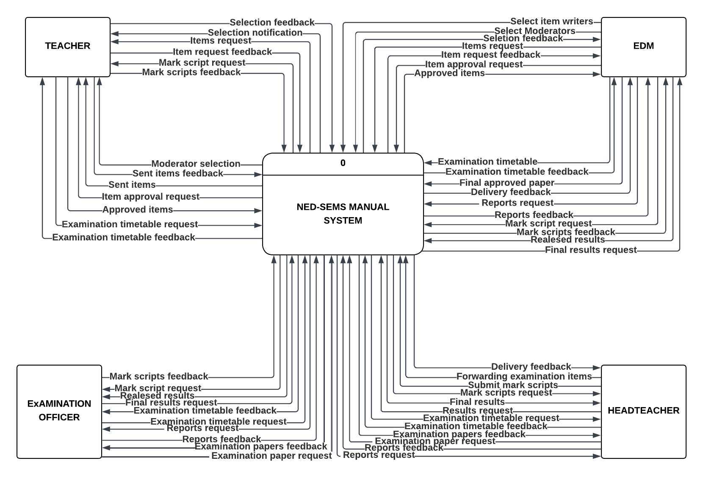
Figure 12: Level 0 for current system
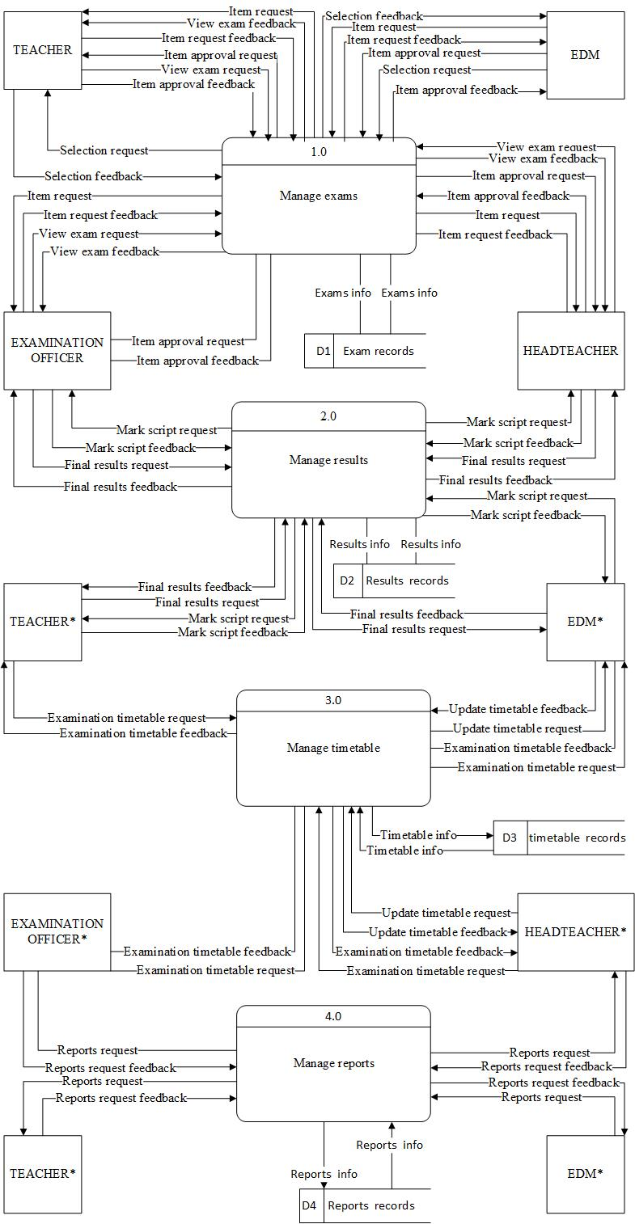
2.3.2 Data Flow Diagrams (Proposed System)
Figure 3: Context diagram for proposed system
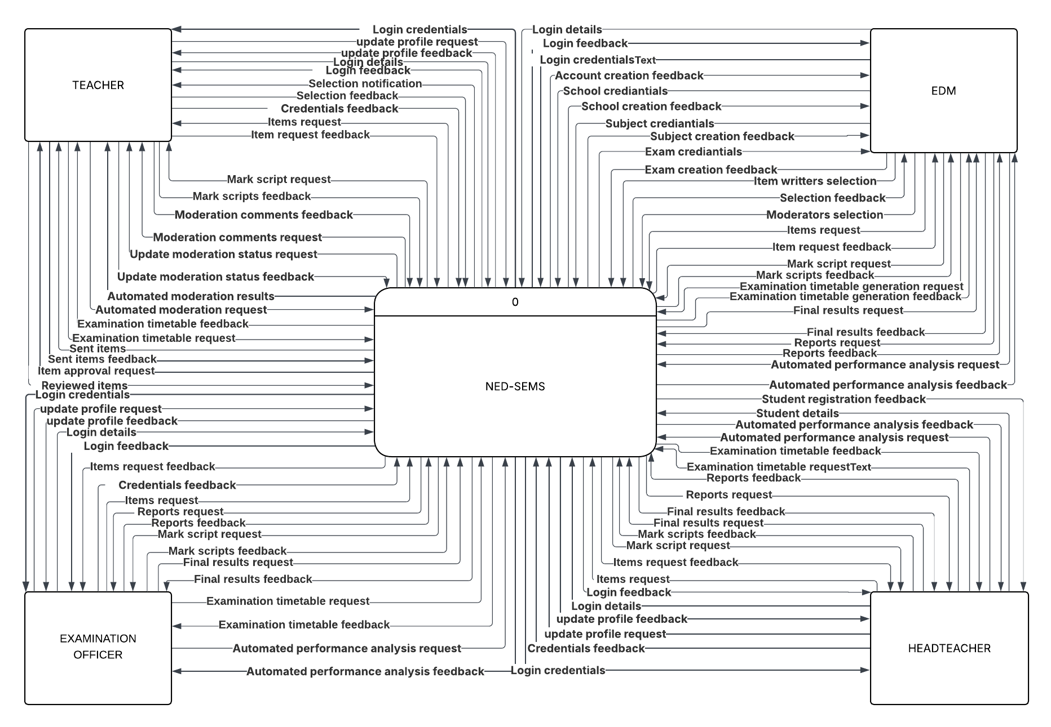

Figure 4: Level 0 for proposed system 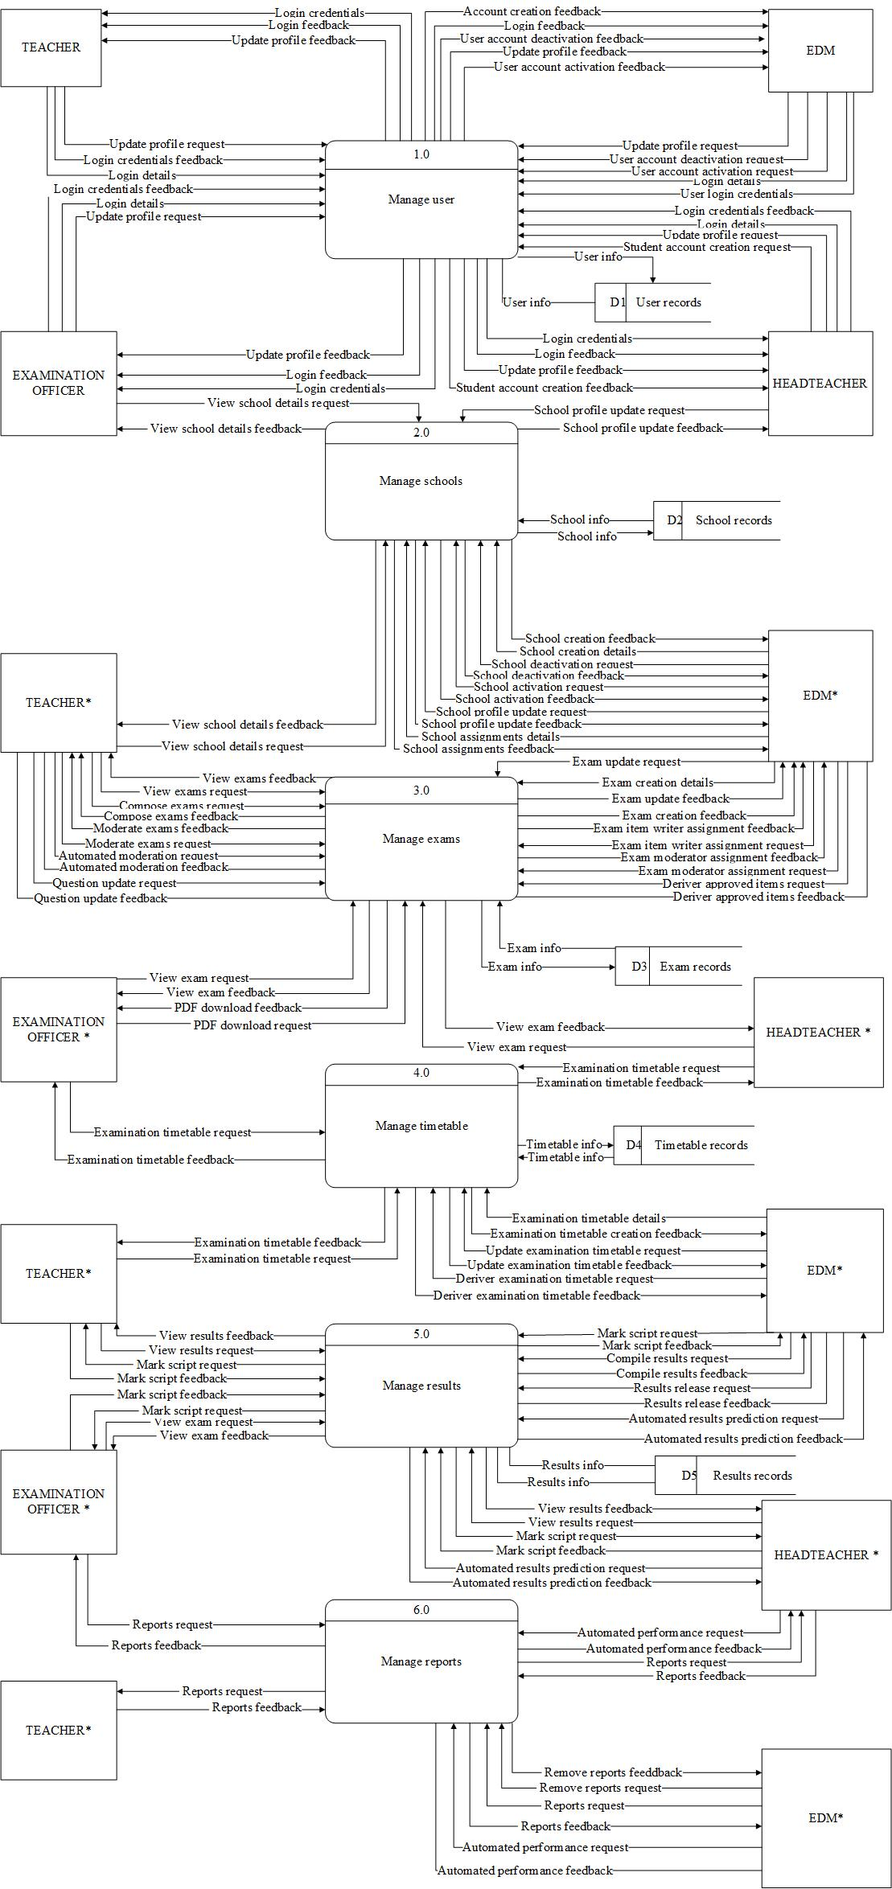

Figure 5: Level 1 for proposed system (Manage exam Process)

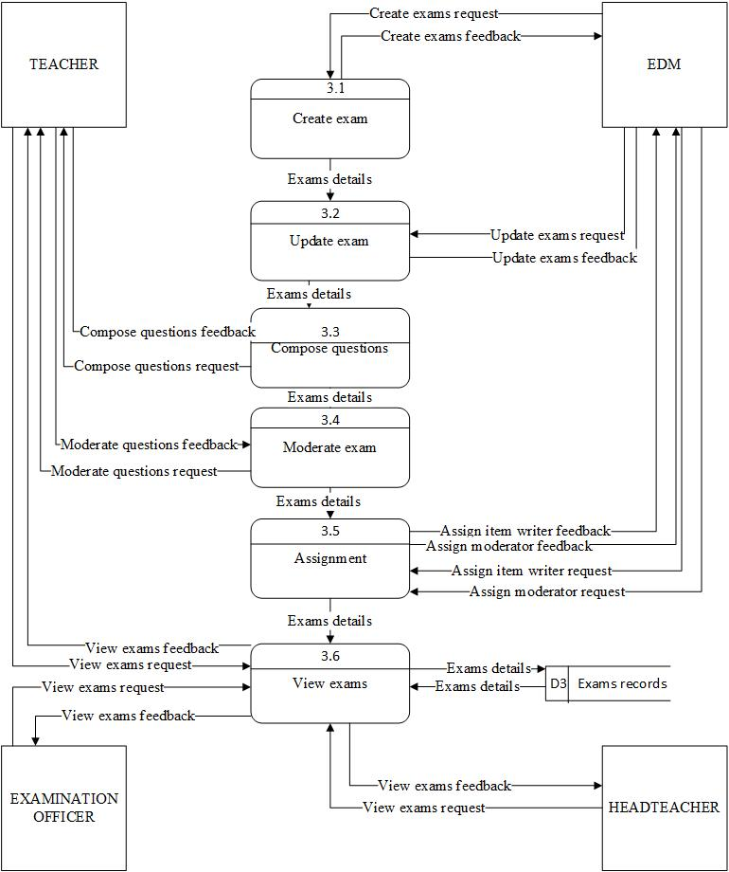

Figure 6: Level 1 for proposed system (Manage results process)
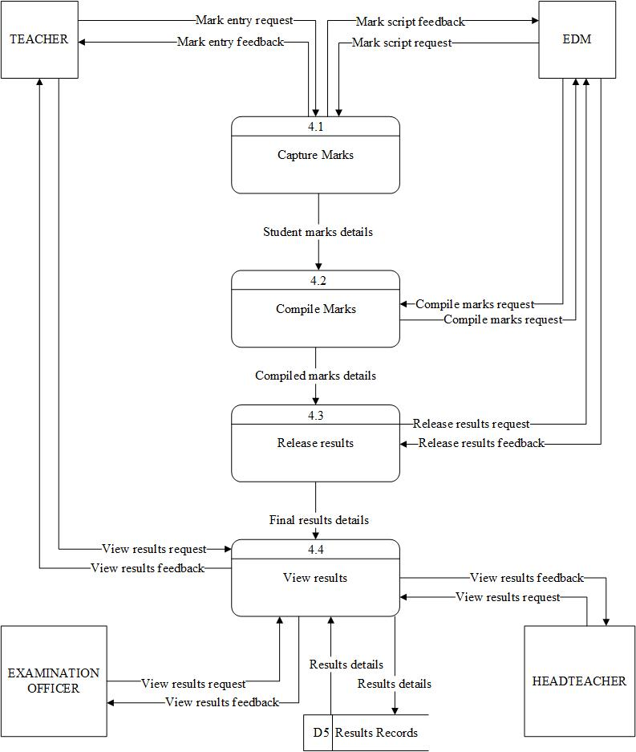

2.4 Description of Components
2.4.1 Process Analysis
Process #: 1.0
Process Name: Manage Users
Attributes: user_id, name, email, phone, password, role, school_id, status, login_count, last_login
Precondition:
• Administrator is authenticated and authorized.
• Database connection is available.
• User management request has been initiated.
Post-condition:
• User account is created, updated, activated, or deactivated.
• User information is stored in the database.
• User role and account status are updated accordingly.
• Notification email is sent when required.
• User activity is recorded in system logs.
Algorithm:
BEGIN Manage Users Process
RECEIVE user management request
AUTHENTICATE administrator
VALIDATE user information
IF request is valid THEN
CREATE user accounts
UPDATE user accounts
ACTIVATE or DEACTIVATE user account
ASSIGN user role and permissions
STORE user information in database
SEND notification email when necessary
RECORD user activity in audit logs
RETURN success message
ELSE
RETURN error message
END IF
END Manage Users Process
Error Handling / Exception Processing:
• Validation Errors: Reject incomplete or invalid user information.
• Duplicate Email Errors: Prevent creation of duplicate user accounts.
• Database Errors: Handle failures during data storage or updates.
• Permission Errors: Prevent unauthorized user management actions.
• Email Delivery Errors: Log notification failures without interrupting the process.
Process #: 2.0
Process Name: Manage Exams
Attributes: exam_id, exam_name, subject_id, created_by, exam_date, duration_minutes,
total_marks, status, year, class
Precondition:
- Administrator is authenticated and authorized.
- Database connection is available.
- Subject records exist in the system.
- Examination management request has been initiated.
Post-condition:
- Examination records are created, updated, assigned, approved, rejected, or deleted.
- Examination information is stored in the database.
- Examination status is updated according to the workflow.
- Teachers and moderators are assigned to examinations.
- Examination content and questions are maintained.
- Examination activities are recorded in the system.
Algorithm:
BEGIN Manage Examinations Process
RECEIVE examination management request
AUTHENTICATE administrator
VALIDATE examination information
IF request is valid THEN
CREATE examination record
ASSIGN subject, year, class, date, duration, and marks
STORE examination information in database
ASSIGN item writers and moderators to examination
ALLOW item writers to compose examination questions
PERFORM AI-assisted question analysis
SUBMIT examination for moderation
REVIEW examination content
APPROVE, REJECT or REQUEST revision
UPDATE examination status
GENERATE examination document for viewing or download
RETURN success message
ELSE
RETURN error message
END IF
END Manage Examinations Process
Error Handling / Exception Processing:
- Validation Errors: Reject incomplete or invalid examination information.
- Subject Errors: Prevent examination creation using invalid subjects.
- Assignment Errors: Prevent assignment to non-existent users.
- Moderation Errors: Handle failures during examination review.
- Database Errors: Handle failures during data storage, retrieval, or updates.
- Permission Errors: Prevent unauthorized examination management actions.
- AI Analysis Errors: Continue examination processing when AI services are unavailable.
- File Generation Errors: Handle failures during examination preview or PDF generation.
Process #: 3.0
Process Name: Manage Results
Attributes:
result_id, exam_id, student_id, teacher_id, total_score, percentage, grade, position_in_class, status, approved_by, published_by, recorded_at, remarks, school_id, class, academic_year
Preconditions
• Teacher is authenticated and authorized.
• Examination exists and is active.
• Students are registered in the system.
• Marks entry period is open.
• Examination Officer, Headteacher and EDM users exist.
• Database connection is available.
• Result management request has been initiated.
Post-conditions
• Student marks are captured and stored.
• Results are reviewed and approved through the workflow.
• AI validates and analyzes examination performance.
• Grades, percentages, rankings, and remarks are generated.
• School-level and district-level results are compiled.
• Final results are published.
• Result records are archived for future reference.
• Result processing activities are logged.
Algorithm:
BEGIN Manage Results Process
RECEIVE marks entry request
AUTHENTICATE teacher
VALIDATE examination and student records
IF marks are valid THEN
CAPTURE student marks
STORE marks in database
APPLY AI mark validation
DETECT missing, duplicate, or abnormal scores
SUBMIT marks to Examination Officer
REVIEW submitted marks
IF approved by Examination Officer THEN
FORWARD results to Headteacher
REVIEW and verify results
IF approved by Headteacher THEN
FORWARD results to EDM Office
COMPILE results from all schools
CALCULATE totals and percentages
GENERATE grades
CALCULATE student rankings
PERFORM AI performance analysis
IDENTIFY top performers
IDENTIFY at-risk students
GENERATE school performance trends
GENERATE district performance statistics
GENERATE AI recommendations
PUBLISH final results
ARCHIVE result records
RETURN success message
ELSE
RETURN results for correction
END IF
ELSE
RETURN marks for correction
END IF
ELSE
RETURN validation error
END IF
END Manage Results Process
Error Handling / Exception Processing
• Validation Errors: Reject invalid, missing, or duplicate marks.
• Examination Errors: Prevent result processing for inactive examinations.
• Student Errors: Prevent processing for non-existent students.
• Approval Errors: Prevent progression without Examination Officer or Headteacher approval.
• Compilation Errors: Handle failures during result calculation and ranking.
• AI Analysis Errors: Continue result processing when AI services are unavailable.
• Publication Errors: Prevent release of incomplete or unapproved results.
• Database Errors: Handle failures during storage, retrieval, or updates.
• Permission Errors: Prevent unauthorized result management actions.
• Network Errors: Handle communication failures during workflow processing.
Process #: 4.0
Process Name: Manage Timetable
Attributes:
timetable_id, exam_id, subject_id, class, exam_date, start_time, end_time, venue, school_id, academic_year, status, created_by, approved_by, published_at
Preconditions
• Administrator is authenticated and authorized.
• Examination records exist in the system.
• Subject records exist in the system.
• School and class information is available.
• Examination timetable management request has been initiated.
• Database connection is available.
Post-conditions
• Examination timetable is created, updated, approved, published, or deleted.
• Examination sessions are assigned dates, times, and venues.
• Timetable conflicts are detected and resolved.
• AI scheduling recommendations are generated.
• Published timetables are available to schools, teachers, and students.
• Timetable activities are recorded in the system.
Algorithm:
BEGIN Manage Timetable Process
RECEIVE timetable management request
AUTHENTICATE administrator
VALIDATE examination information
IF request is valid THEN
SELECT examinations to be scheduled
ASSIGN examination dates
ASSIGN examination times
ASSIGN examination venues
ASSIGN classes and candidate groups
PERFORM AI timetable analysis
DETECT examination clashes
DETECT venue conflicts
DETECT subject scheduling conflicts
GENERATE AI scheduling recommendations
RESOLVE identified conflicts
SAVE timetable information
SUBMIT timetable for approval
REVIEW timetable
APPROVE, REJECT or REQUEST revision
UPDATE timetable status
PUBLISH approved timetable
NOTIFY schools and users
RETURN success message
ELSE
RETURN error message
END IF
END Manage Timetable Process
Error Handling / Exception Processing
• Validation Errors: Reject incomplete or invalid timetable information.
• Examination Errors: Prevent scheduling of non-existent examinations.
• Venue Errors: Prevent allocation of unavailable or overbooked venues.
• Clash Errors: Detect and prevent timetable conflicts.
• Approval Errors: Handle failures during timetable approval.
• Publication Errors: Prevent publication of incomplete timetables.
• Database Errors: Handle failures during data storage, retrieval, or updates.
• Permission Errors: Prevent unauthorized timetable management actions.
• AI Scheduling Errors: Continue timetable processing when AI services are unavailable.
• Notification Errors: Handle failures during timetable distribution.
Process #: 5.0
Process Name: Manage Reports
Attributes:
report_id, report_type, report_name, generated_by, generated_date, examination_id, school_id, district_id, academic_year, report_status, report_format, approval_status, distribution_status
Precondition:
• User is authenticated and authorized.
• Examination and results data exist in the system.
• Schools, students, examinations, and performance records are available.
• Database connection is available.
• Report generation request has been initiated.
• Required examination results have been approved.
Post-condition:
• Performance reports are generated successfully.
• Statistical summaries are calculated and stored.
• AI-generated insights and recommendations are attached to reports.
• Reports are approved by authorized officers.
• Reports are distributed to intended stakeholders.
• Reports are archived for future reference.
• Report generation activities are logged.
Algorithm:
BEGIN Manage Reports Process
RECEIVE report generation request
AUTHENTICATE user
VALIDATE report parameters
IF request is valid THEN
FETCH examination, student, school and performance data
CALCULATE statistics
GENERATE report structure
COMPUTE averages, grades, pass rates and rankings
PERFORM AI-powered performance analysis
IDENTIFY performance trends and anomalies
PREDICT future examination performance using AI
GENERATE AI recommendations for improvement
CREATE report document
GENERATE charts, graphs and dashboards
SUBMIT report for approval
IF approved THEN
PUBLISH report
DISTRIBUTE report to schools and education offices
ARCHIVE report
LOG report activities
RETURN success message
ELSE
RETURN approval pending message
END IF
ELSE
RETURN error message
END IF
END Manage Reports Process
Error Handling / Exception Processing:
• Validation Errors: Reject incomplete report parameters.
• Data Availability Errors: Prevent report generation when examination data is unavailable.
• Calculation Errors: Handle failures during statistical computations.
• Approval Errors: Prevent publishing of unapproved reports.
• Distribution Errors: Handle failures during report delivery.
• Database Errors: Handle failures during report storage or retrieval.
• Permission Errors: Prevent unauthorized report generation or access.
• AI Analysis Errors: Continue report generation when AI services are unavailable.
• File Generation Errors: Handle failures during PDF, Excel, or dashboard report creation.
• Archiving Errors: Handle failures during report storage and retention.
3.0 External System Interfaces
This examination management system will have to work with other external systems in order to achieve its objectives as a system. The system will integrate with a MySQL database management system where data relating to users, examinations, timetable, results, and reports is stored and managed. In order to make decisions more efficient and easier, the system will interface with artificial intelligence services where questions from examinations will be analyzed, student performance predicted, anomalies detected and reports automatically generated. The system will also interface with an email system where emails are sent as notification of account verification, password recovery, examination, and report distribution. These external interfaces shall collectively enable efficient data management, intelligent analysis, secure communication, and effective delivery of examination management services.
4.0 Data Architecture
4.1 Data Dictionary
Table 1: List of tables in the system
Name | Column Number | Description
Users | 12 | Stores user accounts, login credentials, roles, school affiliation, and account status.
Schools | 6 | Stores school information including name, district, division, address, and status.
Students | 6 | Stores student biodata, examination numbers, school allocation, class, and status.
Subjects | 3 | Stores subject names and subject status used in examinations.
Teacher_Subjects | 3 | Stores subject assignments allocated to teachers.
Exams | 10 | Stores examination details including subject, creator, examination date, duration, marks, and workflow status.
Questions | 17 | Stores examination questions, answer options, marks allocation, AI scores, and moderation status.
Exam_Assignments | 8 | Stores examination assignments issued to item writers and moderators.
Exam_Documents | 8 | Stores uploaded examination papers, marking schemes, document versions, and file locations.
Exam_Comments | 5 | Stores comments and feedback provided during examination review and moderation.
Moderation | 7 | Stores examination moderation decisions, reviewer comments, and approval status.
Question_Moderation | 6 | Stores moderation outcomes and comments for individual examination questions.
Exam_Workflow_Logs | 7 | Stores examination workflow activities, actions performed, responsible users, and timestamps.
Marks | 9 | Stores student examination marks, teacher submissions, remarks, and approval status.
Results | 17 | Stores final examination results, grades, percentages, rankings, approval status, and locking information.
Result_Workflow_Logs | 9 | Stores result approval workflow activities, status transitions, and audit information.
School_Reports | 9 | Stores school performance reports including attendance rates, pass rates, and comments.
School_Notes | 8 | Stores school assessment notes, attendance records, observations, and recommendations.
Audit_Logs | 5 | Stores user activities and audit trail information for accountability and security purposes.
Password_Resets | 6 | Stores password recovery requests, OTP codes, expiration dates, and usage status.
AI_Moderation_Logs | 8 | Stores AI-generated analysis of examination questions including Bloom's level, complexity, and quality scores.
AI_Alerts | 6 | Stores AI-generated alerts related to examination leakages, anomalies, and security violations.

4.3 Database Schema
Table 2: Users Table
Column Name | Primary Key | Data Type | Null
user_id | Yes | INT | No
name | No | VARCHAR(255) | No
email | No | VARCHAR(191) | No
phone | No | VARCHAR(20) | Yes
password | No | VARCHAR(255) | No
role | No | ENUM | No
school_id | No | INT | Yes
status | No | VARCHAR(20) | Yes
deleted_at | No | DATETIME | Yes
deleted_by | No | INT | Yes
login_count | No | INT | Yes
last_login | No | DATETIME | Yes

Table 3: Schools Table
Column Name | Primary Key | Data Type | Null
school_id | Yes | INT | No
school_name | No | VARCHAR(255) | No
district | No | VARCHAR(100) | No
address | No | TEXT | Yes
division | No | VARCHAR(100) | No
status | No | ENUM | Yes
Table 4: Students Table
Column Name | Primary Key | Data Type | Null
student_id | Yes | INT | No
name | No | VARCHAR(255) | No
school_id | No | INT | Yes
class | No | ENUM | Yes
exam_number | No | VARCHAR(50) | No
status | No | ENUM | Yes
Table 5: Subjects Table
Column Name | Primary Key | Data Type | Null
subject_id | Yes | INT | No
subject_name | No | VARCHAR(100) | No
status | No | VARCHAR(20) | No
Table 6: Exams Table
Column Name | Primary Key | Data Type | Null
exam_id | Yes | INT | No
exam_name | No | VARCHAR(255) | Yes
subject_id | No | INT | No
created_by | No | INT | No
exam_date | No | DATE | Yes
duration_minutes | No | INT | Yes
total_marks | No | INT | Yes
status | No | ENUM | Yes
year | No | YEAR | Yes
class | No | ENUM | Yes
Table 7: Questions Table
Column Name | Primary Key | Data Type | Null
question_id | Yes | INT | No
exam_id | No | INT | No
question_order | No | INT | Yes
question_text | No | TEXT | No
marks | No | INT | No
created_by | No | INT | Yes
section_name | No | VARCHAR(100) | Yes
created_at | No | TIMESTAMP | Yes
question_type | No | VARCHAR(20) | No
option_a | No | VARCHAR(255) | Yes
option_b | No | VARCHAR(255) | Yes
option_c | No | VARCHAR(255) | Yes
option_d | No | VARCHAR(255) | Yes
correct_option | No | CHAR(1) | Yes
ai_score | No | FLOAT | Yes
moderation_status | No | ENUM | Yes
moderator_comment | No | TEXT | Yes
Table 8: Exam Assignments Table
Column Name | Primary Key | Data Type | Null
assignment_id | Yes | INT | No
exam_id | No | INT | No
teacher_id | No | INT | No
role | No | ENUM | No
assigned_by | No | INT | No
assigned_at | No | DATETIME | Yes
email_sent | No | BOOLEAN | Yes
status | No | VARCHAR(50) | Yes
Table 9: Moderation Table
Column Name | Primary Key | Data Type | Null
moderation_id | Yes | INT | No
exam_id | No | INT | No
reviewer_id | No | INT | No
comments | No | TEXT | Yes
status | No | ENUM | No
review_date | No | DATETIME | Yes
version_number | No | INT | Yes
Table 10: Results Table
Column Name | Primary Key | Data Type | Null
result_id | Yes | INT | No
student_id | No | INT | No
exam_id | Not | INT | No
total_score | No | DECIMAL(5,2) | Yes
grade | No | VARCHAR(5) | Yes
remarks | No | TEXT | Yes
position_in_class | No | INT | Yes
percentage | No | DECIMAL(5,2) | Yes
recorded_by | No | INT | Yes
recorded_at | No | DATETIME | Yes
status | No | ENUM | Yes
teacher_id | No | INT | Yes
editable_until | No | DATETIME | Yes
Locked | No | BOOLEAN | Yes
submitted_at | No | DATETIME | Yes
submitted_by | No | INT | Yes
Table 11: School Reports Table
Column Name | Primary Key | Data Type | Null
report_id | Yes | INT | No
school_id | No | INT | No
Term | No | VARCHAR(20) | Yes
Year | No | INT | Yes
total_students | No | INT | Yes
attendance_rate | No | FLOAT | Yes
pass_rate | No | FLOAT | Yes
Comments | No | TEXT | Yes
created_at | No | TIMESTAMP | Yes
8.0 Graphical User Interface
8.1 Description of the User Interface
8.1.1 Screen Images

10.0 System Requirements
10.1 Functional Requirements
REQ.NO | REQUIREMENT | DESCRIPTION
1 | The system shall allow users to log into the system using unique credentials. | The system shall authenticate users based on their assigned roles and deny access to unauthorized functions.
2 | The system shall allow Item Writers to compose questions along with relevant metadata, and securely store all documents. | Documents shall be stored in encrypted storage with restricted access, including metadata such as subject, class, exam type, and date.
3 | The system shall notify Moderators of exam papers awaiting review, and allow them to approve or reject papers. | Moderators shall provide comments, corrections, and revision requests for all submissions.
4 | The system shall notify the Education Division Manager (EDM) when papers pass moderation, enabling final review. | The EDM shall perform the final approval before the exam release.
5 | The system shall provide real-time, role specific notifications for key actions. | Notifications shall cover submissions, moderation results, approvals, and exam releases.
6 | The system shall restrict access to exams until the official release date. | Exams shall remain locked and inaccessible until the scheduled date.
7 | The system shall generate reports for all system activities. | Reports shall include submission logs, moderation logs, approvals, and compliance records.
8 | The system shall allow administrators to create and manage user accounts and roles. | Administrators shall be able to add, update, deactivate, and delete system users.
9 | The system shall prevent unauthorized download or printing of exam papers. | Access restrictions shall maintain exam confidentiality throughout the workflow.

10.2 Interface Requirements
Req.  No. | Requirement | Description | External  System
2 | The system shall validate user information internally. | The system shall verify teacher, headteacher, examination officer, and EDM registration details using internal NED-SEMS records and display a confirmation message when the information is valid. | None (Internal  Module)
7 | The system shall send automated notifications to users. | The system shall use PHPMailer to send emails for registration confirmation, moderation feedback, paper approvals or rejections, submission alerts, and password reset requests. | PHPMailer  (Email Sending  Library)

10.3 Non-Functional Requirements

10.3.1 System-Related Non-Functional Requirements
Req.  No | Non-Functional  Requirement | Description | Affected  Req. No
1 | Security | The system shall protect user accounts by hashing all passwords using BCRYPT and allowing only authenticated users to access exam materials. This ensures the confidentiality of sensitive examination documents. | 1, 2, 3, 4, 8, 9
2 | Performance | With stable internet, the system shall process uploads, approvals, notifications, and report generation within reasonable time. This ensures a smooth experience for teachers, moderators, EDM, and examination officers. | 2, 3, 4, 5, 7
3 | Accuracy | The system shall store examination papers, user profiles, moderation feedback, and results accurately and consistently to maintain the integrity of examination records. | 2, 3, 4, 5, 7
4 | Privacy | Each user shall only access information permitted by their role. This prevents unauthorized access to confidential exam materials and internal system data. | 1, 2, 3, 4, 6, 9
5 | Modifiability | The system shall be developed in a way that supports future updates such as new reports, AI analytics, or SMS notifications without needing major redesign. | 1–9

6.3.2 User-Related Non-Functional Requirements
- Skill Level
Users with basic computer knowledge shall be able to operate the system without requiring technical expertise.
- Training
System usage training shall take approximately a week for all users to get familiar with the system as long as they know computer usage. A user manual shall also be created which shall show how to perform tasks in the system
11.0 Appendices
12.0 Glossary
Term | Definition
AI(Artificial  Intelligence) | A field of computer science that enables machines or systems to simulate human intelligence processes such as learning, reasoning, and problem-solving.
Agile Methodology | A flexible and iterative software development approach that focuses on collaboration, user feedback, and continuous improvement through incremental development cycles.
Examination  Management System  (EMS) | A digital platform that automates processes involved in exam preparation, moderation, administration, and reporting.
NED-SEMS | The proposed Northern Education Division Smart Examination Management System a web-based intelligent platform designed to enhance efficiency, transparency, and security in examination management.
EDM(Education  Division Manager) | The head of the education division responsible for overseeing examination activities and general education management within the Northern Division.
Data Analytics | The process of examining data sets to identify patterns, trends, and insights that support informed decision-making.
Performance Trends | Patterns or changes observed in students’ academic performance over time.
Examination  Irregularities | Any unauthorized actions or practices that compromise the integrity, fairness, or security of examinations.

9.0 References
- Ministry of Education, Science and Technology (Malawi) (MoEST). (2024). Education Sector Performance Report 2024. Government of Malawi, Lilongwe.
- UNESCO.(2021). ICT Integration in Sub-Saharan African Education Systems. Paris: UNESCO.
- Mphahlele, N. S., Kekwaletswe, R. M., & Seaba, T. (2024). Change management model for effective use of examination administration system: Developing country case study. Journal of Information Systems and Informatics, 6(1), 187-219.
- Adebayo, A., & Abdulhamid, A. (2023). Examination malpractice and data security challenges in Nigerian schools. International Journal of Educational Management, 37(2), 145–162.
- Wang, X., Li, Y., & Chen, H. (2024). Artificial intelligence and data analytics for education management: Enhancing efficiency and decision-making. Journal of Educational Technology & Society, 27(1), 101– 118.
- Olanrewaju, F., Moyo, T., & Mensah, K. (2025). AI adoption in African education: Opportunities and challenges. African Journal of Educational Technology, 12(2), 55–76.
- K. Beck et al.( 2001). Manifesto for Agile Software Development, Agile Alliance.
- R. K. Yin (2018) Case Study Research and Applications: Design and Methods, 6th ed. Thousand Oaks, CA: Sage Publications.
- J. W. Creswell and J. D. Creswell. (2018). Research Design: Qualitative, Quantitative, and Mixed Methods Approaches, 5th ed. Los Angeles, CA: Sage Publications.
- L. Guidone, “Risks of manual document processing,” myBiros, 2023. [Online]. Available: https://www.mybiros.com/en/post/risks-of-manual-document-processing
- R. Korte, G. Arnolds, and J. Osten, “Causes and consequences of fragmented process information:
Insights from a case study,” ResearchGate, 2017. [Online]. Available:
https://www.researchgate.net/publication/316580108_Causes_and_Consequences_of_Fragmented_P rocess_Information_Insights_from_a_Case_Study

